COAL Lab 11
Task 1:
include irvine32.inc

.data
salary dword 1000
allow dword 500
msg byte "Updated salary is: ",0

.code
main proc
push salary
push allow
call calcSalary
mov edx,offset msg
call writeString
call writeDec
call crlf
exit
main endp

calcSalary proc
push ebp
mov ebp,esp
mov eax,[ebp+12]
add eax,[ebp+8]
pop ebp
ret
calcSalary endp
end main
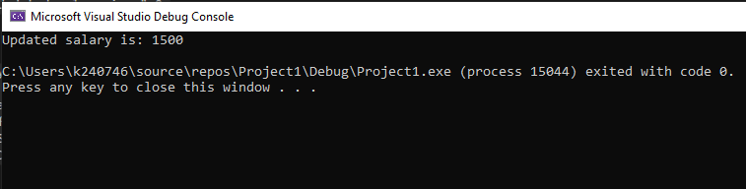

Task 2:
include irvine32.inc

.data
cycle_time dword 100
water_level dword 500
temperature dword 10
result dword ?
msg byte "Result is: ",0

.code
main proc
mov ebx,cycle_time
mov ecx,water_level
mov edx,temperature
call washCycle
mov edx,offset msg
call writeString
mov eax,result
call writeDec
call crlf
exit
main endp

washCycle proc uses ebx ecx edx
push edx
mov eax,ebx
mul ecx
pop edx
add eax,edx
mov result,eax
ret
washCycle endp
end main
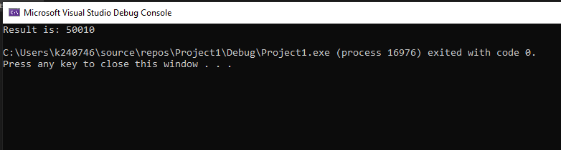

Task 3:
include irvine32.inc

.data
array dword 10,20,30,40
categ dword 4
msg byte "Total books are: ",0

.code
main proc
push offset array
push categ
call sum_books
mov edx,offset msg
call writeString
call writeDec
call crlf
exit
main endp

sum_books proc
push ebp
mov ebp,esp
mov esi,[ebp+12]
mov ecx,[ebp+8]
mov eax,0
L1:
add eax,[esi]
add esi,4
loop L1
pop ebp
ret
sum_books endp
end main
